

08

Fall

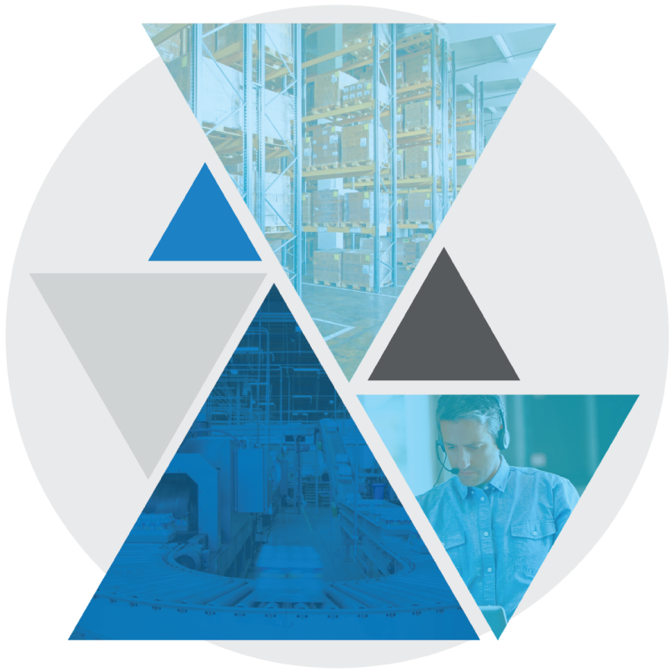

**Test Case: BASE-YRD-1040**

**Web Outbound Trailer Check In**

Table of Contents

Web Outbound Trailer Check In 3

Test Case Setup 3

Test Case Cleanup 3

Test Case Prerequisites and Assumptions 4

Test Case Examples 4

Test Case Configurations 5

Test Case Verification Approach 5

Test Case Specification 5

Web Outbound Trailer Check In

This document documents the test case instructions for the BASE-YRD-1040 Bundle Test Case implementing Web Outbound Trailer Check In.

**Please note**: The inputs used in these test case specifications (defined in the input CSV files or Datastore) are relative to our testing warehouse environment and are provided as examples. These inputs should be substituted with valid inputs relative to your WMS environment.

Test Case Setup

* Test Case Background function will run the standard set of setup scenarios for the bundle.
* Test Case Dataset
  + Creates a trailer if applicable
  + Checks in the trailer to the specified dock location

Test Case Cleanup

* The Test Case After Scenario will run the standard cleanup actions for the bundle.   
  **NOTE:** This including logging out of all interfaces (Terminal and Web).
* Data created during dataset creation and execution is cleaned up.

Test Case Prerequisites and Assumptions

* Dock door is available for check in
* Process assumes check in without appointment

Test Case Examples

This Test Case will only perform Web Outbound Trailer Check In and will not perform any other examples of this function.

Test Case Configurations

The Test Case will be run in the following test configurations:

* Blue Yonder Web UI
  + Google Chrome
  + Microsoft Edge

Test Case Verification Approach

This test will verify screen data in-line within the test step sections.

It will also Utilize a MSQL WMS query to validate that the anticipated end state was reached.

Test Case Specification

|  |  |
| --- | --- |
| **Test Case:** BASE-YRD-1040 Web Outbound Trailer Check in | **Description:** Web Outbound Trailer Check In **Functional Area:** Outbound **Test Case Type:** Regression **Dataset:** NA **Test Case Inputs:** Test Case Inputs/BASE-YRD-1040.csv  **Duration:** 1 minute |

|  |  |
| --- | --- |
| **Steps, Actions, and Expected Results** | **Supporting information and/or Affected Data** |
| **Step 1**: Sign into the Web UI using your relevant Username and Password  **Actions**:   * Enter Username and Password * Click on the **Sign In** button   **Expected Results**:   * User successfully logs on to web |  |

|  |  |
| --- | --- |
| **Step 2**:  Search for Transport Equipment Web screen  **Actions**:   * Type ‘Transport Equipment’ in JDA search field and press ENTER   **Expected Results**:   * Relevant pages should be returned from the search. |  |

|  |  |
| --- | --- |
| **Step 3**: Navigate to *Transport Equipment* Web page  **Actions**:   * Select **Receiving -> Transport Equipment**   **Expected Results**:   * *Transport* *Equipment* screen is open now |  |

|  |  |
| --- | --- |
| **Step 4**:  Navigate to the *Add Transport Equipment* windows  **Actions**:   * Click into the **Actions** drop down menu * Click on the Add Transport equipment Option   **Expected Results**:   * *Add Transport Equipment* windows is now open |  |
| **Step 5**: Insert relevant Equipment attributes  **Actions**:   * Enter in the following data (defined in input file): * Equipment Number: TRK1040 * Carrier: CYCCAR1 * Use: Shipping * Type: Truck/Transport Equipment * Exit the window   **Expected Results**:   * *Transport Equipment* screen now shows TRK1040 |  |

|  |  |
| --- | --- |
| **Step 6**:  Search for Transport Equipment Web screen  **Actions**:   * Type ‘Transport Equipment’ in JDA search field and press ENTER   **Expected Results**:   * Relevant pages are returned from the search. |  |

|  |  |
| --- | --- |
| **Step 7**: Navigate to Transport Equipment Web page  **Actions**:   * Select **Receiving -> Transport Equipment**   **Expected Results**:   * *Transport* *Equipment* screen is open now |  |

|  |  |
| --- | --- |
| **Step 8**: Search for trailer  **Actions**:   * Click the Quick Filters search bar * Type ‘TRK1040’ (defined in input file) * Click ENTER   **Expected Results**:   * TRK1040 is now the only Transport Equipment featured in the list |  |

|  |  |
| --- | --- |
| **Step 9**: Search for Check In  **Actions**:   * Type ‘Transport Equipment’ in JDA search field * Click ENTER   **Expected Results**:   * *Check In* page is now visable |  |

|  |  |
| --- | --- |
| **Step 10**: Search for desired Transport Equipment  **Actions**:   * Type ‘TRK1040’ in the Transport Equipment search bar * Press ENTER   **Expected Results**:   * Check In options for TRK1040 are now visable * User is on *Locations* page |  |

|  |  |
| --- | --- |
| **Step 11**: Check In trailer  **Actions**:   * Select desired dock location within the Locations list * Click the **Check In** button   **Expected Results**:   * *Check In Successful* pop up is now visable |  |

|  |  |
| --- | --- |
| **Final State:** Check In Successful screen is now visable  Displays trailer information within pop up  Standard test verification and log off functions are performed |  |